SOFTWARE DESIGN INVITATIONAL SUBMISSION PROPOSAL
eduGRID: REVOLUTIONIZING THE CONCEPT OF EDUCATION



1. PROJECT DETAILS

1.1) Application Name

eduGRID

1.2) Team Name

GRAS

1.3) Team Members (Name, Department, Faculty and School)
Roshan Sumbaly, Computer Science Department, BITS Pilani – Goa Campus
Abhishek Kumar, Information Systems Department, BITS Pilani – Goa Campus
Shubham Malhotra, Electronics and Instrumentation Department, BITS Pilani – Goa Campus
Gaurav Paruthi, Electrical and Electronics Engineering Dept, BITS Pilani – Goa Campus

1.4) Development Technologies Used
- .NET Framework 2.0
- .NET Framework 2.0 based Alchemi toolkit library for construction of Grid architecture
- Ms Conference XP (A Microsoft Research Initiative) framework
- Visual Studio Express Edition 2005
- BizTalk
- AIMLBot Class in C# (www.aimlbot.sourceforge.net)
- Microsoft SQL Server 2005
- Microsoft IIS Server Version 5.1
- ASP.NET 2.0, ASP.NET Web Services
- Smart Device Client Application
    - Application Interface for Pocket PC 2003
    - Application Interface for Smartphone 2003
    - Application Interface built for Windows CE 5.0 or later.

2. DESCRIPTION

2.1) Introduction

Imagine a world where education is free, interesting and unifying; imagine a world where technology itself drives education. This is what we seek to achieve through our project eduGRID.

Our project aims to create a Grid-Enabled Application that uses the computational power of the GRID and its distributed nature to answer specific queries of students and teachers alike as accurately as possible in an intelligent and conversational manner. The bots have been designed to be self learning and constantly update their Knowledge bank in response to the nature of queries asked. Other features include virtual classroom, teacher-student interaction, and various business models as mentioned in subsequent sections.

2.2) Project Motive

Decades ago knowledge was restricted to certain locations across the globe and this resulted in “sporadic knowledge.” Now in the 21st century we face a crisis of information overload and separating the wheat from chaff is essentially what is required.

eduGRID – a complete Grid infrastructure as its backbone (“world”) can be used to gather this disseminated knowledge. Specialized intelligent bots (“technology drives education”) trained using the free computation cycles (“education is free”) of the Grid and backed with knowledge of all the experts and researchers (“interesting and unifying”) from diversified fields will be ready to answer any question.


Intelligent
Conversational
Self Learning
Accurate
eduGRID Framework
eduGRID Framework: A Layman’s view of the system
GRID of
computers
event
Manager
Profile
Manager
Target Users
- Students
- Teachers
- Researchers
- Other Users
Bot
Course
Manager
Personal
educator
Cache
Manager

2.3) Project Overview

eduGRID is the solution to today’s shortage of qualified teachers in the face of exploding population; in fact it is the solution to the shortage of teachers itself. eduGRID essentially is a cluster of computers running an Artificially Intelligent program that will not only intelligently answer queries of students and teachers alike, but will eventually become the educator. Sudents and teachers will login to the eduGRID and can learn through interactive tutorials or simply post questions to which the intelligent bot will reply - crisp and to the point. The ability to follow conversations and adapt to the each individual person's tastes will make it a more effective teaching aid if not a replacement itself.

Again, a project with zero investment, eduGRID is the solution to today’s problem of increasing digital-divide. It provides a means for a student from anywhere in India (or for that respect, the world) to interact with a teacher or professor in a different part of the world (This, we achieve through a Microsoft Research Project – ConferenceXP, which we have added onto the eduGRID framework).

In this sense, the eduGRID is a smart personalized bot that educates the student in diverse course content in an intellectual and conversational manner. With personalization of accounts, it will also be possible to store interests, learning pattern and knowledge sought by each individual user. The longer one uses the eduGRID, the more personalized it becomes. In this way, eduGRID will fine tune itself for each individual user. In some sense, it will achieve what the best teachers seldom manage to achieve: pay unique attention to each individual student!

Interactive Learning
Narrow Digital Divide
Personalization
Self Learning

2.4) Business Model – Brief Overview

eduGRID enables better education for people in urban and rural areas and provides opportunities for interaction and learning.

The intelligent conversational bot can also be trained to assume the role of a Help-Desk or Intelligent Assistant for company products.

By deploying the grid architecture at small scale level, the eduGRID framework can be used by companies to educate employees about specific fields.

All these Applications provide innovative business models for our project.

In addition, the web-based conversational bot can make use of intelligent advertising (but not violating any privacy policy) for revenue.

Moreover, teachers/faculty can chose to provide their services (for learning sessions or workshops) for both free and charge, according to their will making it an ideal platform to serve the public as well as an opportunity to earn revenue.

2.5) Project Impact
- eduGRID will solve problems in places where experts are inapproachable. Using eduGRID, answers to your questions are just a click away.
- eduGRID will be initially aimed to cater to the needs of “students and faculty.” It can subsequently be expanded to cover distinct levels in society. We imagine a day to come when farmers will have all their doubts answered, probably even in their native language using a preconfigured self-learning bot.
- eduGRID can be used to solve day to day life / health problems by imparting education to users. For example, imagine a database of health based questions. Users can log into the eduGRID and feed their health problems which can easily be diagnosed by our “self adaptive educated Bot” whose database is updated on a regular basis. A portal like this can be an ideal location for creating awareness about health hazards like AIDS.
- eduGRID's realm extends beyond technical education. eduGRID can also cater to moral issues in the society. A major problem faced by teenagers is the lack of “sex education.” This can easily be dealt with in a more effective way by having a self adaptive bot which can provide answers depending on the users response and thereby act as a reliable source of information.
- eduGRID can eventually prove to be a child's best friend and educator. With advanced features like “voice enabled answers” eduGRID can prove to be a common man’s friend. A reliable source of information coupled with interactivity will make this an intelligent prosthesis of education in the global society.

2.6) Target Users of eduGRID

eduGRID assumes different roles for different users as necessary through a Profile Manager. The major functionality on basis of broad user classification is as follows:

2.6.1) Students:
- Answer student queries, clear doubts and educate in conversational manner.
- Course education: teach the student various courses in a conversational and interesting manner. Conventional modes of exams may be replaced by a method where the bot asks a question and corrects the student’s reply immediately. The examination is no longer a “tension” but a wonderful learning experience.
- Enable interaction of students with professors/teachers across the globe to provide an easy learning environment or an interactive workshop and narrow the digital divide.
2.6.2) Teachers:
- Provide access to course content and precise information on related topics through intelligent conversation.
- Allow interaction with students in disparate locations for learning session.
- Encourage the teacher to train the bot so as to effectively educate students.

2.6.3) Other General Users
- Provide an educated platform for accurate replies on user queries. The Ability to follow conversations shall make eduGRID an intelligent search mechanism for information on a variety of topics.
- The interface for other users have been integrated into various existing applications:
  - eduGRID Bot in MSN Messenger.
  - MSN Sidebar Gadget which interacts with the eduGRID framework.
  - IE 7 Add on that enables easy conversational learning delivered as and when required.
  - Ms Office Integration: the eduGRID client may be integrated within Ms Office so that “on the fly” responses to various user queries can be done. For e.g., if a user selects “ISRO” within a word document, the client would do an on-the-fly query and a tooltip would appear indicating that “ISRO stands for Indian Space Research Organization ... etc …”

2.6.4) Personalization of Bots as per different aspects of users

- In addition to having a general bot for user queries, eduGRID will also have bots which are personalized and specialized on specific basis.
- For e.g., A variant of the eduGRID bot could be specialized in health-care and personalized to a particular user (Say Mr. A. who has diabetes). In this case, all health related questions asked to this bot would be replied to in context of a diabetic patient.
- Similarly other bots could be trained in different functionality and could be as useful as a ready intelligent encyclopedia or as innovative as a schedule planner.
- Based on the training provided, the bots could be specialized in a variety of different and diverse fields to assist personnel in a variety of different jobs. For eg, an archaeologist could be provided with a bot specialized in archeology and history.

Generic Bot
- Makes use of General Knowledge KB
Specialization
Specialized Bot
- Makes use of General Knowledge KB
+ Specialized Knowledge Base
+ Personalized Knowledge Base
Refer section 6 for further details

2.7) Components of eduGRID
2.7.1) The Webservice

The eduGRID webservice is responsible for authentication and serves as a broker between client Applications and the central Application Manager of eduGRID. In some sense, it acts as the middleware between client and the “real” server – i.e. the Central Manager of the GRID Framework.
2.7.2) User Interface/Client:

This is the primary mode of interaction for the user. We have built several different user interfaces for interaction with the user:
- A Client Application for students. Provides an easy to use interface with the bot as well as addon tools such as calendar and schedule…
- An interface designed and implemented as a user/friend within Ms Live Messenger.
- An integrated addon within Ms Office itself so that “on the fly” responses to various user queries can be done. For e.g., if a user selects “ISRO” within a word document, the client would do an on-the-fly query and a tooltip would appear indicating that “ISRO stands for Indian Space Research Organization ... etc …”
- We are still working on integration of the eduGRID framework and the bot within ConferenceXP and as an IE7 addon.
- The web interface is an interface providing a facility to converse with a general (as opposed to specialized) bots for educational and informational purposes.
2.7.3) Central Application Manager and the GRID Framework:
- One of the most important component of our project
- This is the backbone of eduGRID and supports the bots.
- Further information is available in section 6.

2.7.4) Profile Manager
- Used for managing profile of users and personalization of information.

2.7.5) Event Manager
- Used for managing events such as workshops and online learning sessions organized by professors/teachers.

2.7.6) Learn Assistant
- eduGRID makes use of Microsoft Live Search API in order to obtain latest and accurate information on frequently asked topics from the world wide web.

2.7.7) The intelligent Bot based on AIML
- This is the “brain” of our project. Further information in section 6.

2.8) User Scenarios

2.8.1) Scenario 1: Student Session
- Student Logs in to the eduGRID framework with username and password.
- He/she is presented with the set of courses that are part of syllabus.
- The student may ask the bot any query regarding the course, or in general.
- In case the student feels he/she has completed or finished a particular course, he/she will have to take a simple test for examination purpose.
- The specific course modules and structure can be altered or enhanced through training of the bot by teachers.
- The client Application also houses additional add-ons which include a course planner, schedule, calendar etc…
- Additional proposed features that we are working on include virtual conferences with teachers, virtual classrooms etc, making use of conferenceXP.
- An example screenshot is presented in next section (3).:

2.8.1) Scenario 2: Web Interface
- The web interface is linked to a webservice which takes care of authorization and connection to the grid.
- The web interface is catered towards all users and provides a generic bot which answers user queries in an intelligent and conversational way.

2.8.3) Scenario for Teachers, researchers and professors
- The client Application for teachers supports specialized bot depending on the field of the teacher.
- For e.g. a teacher who has a phd in physics would prefer to interact with a bot specialized in physics so that the answers to query is scientific in nature and not childish.

3. USER INTERFACE

3.1) eduGRID Framework: User interface
The eduGRID Framework Client Application sports an innovative user interface and promises to offer the user a unique experience

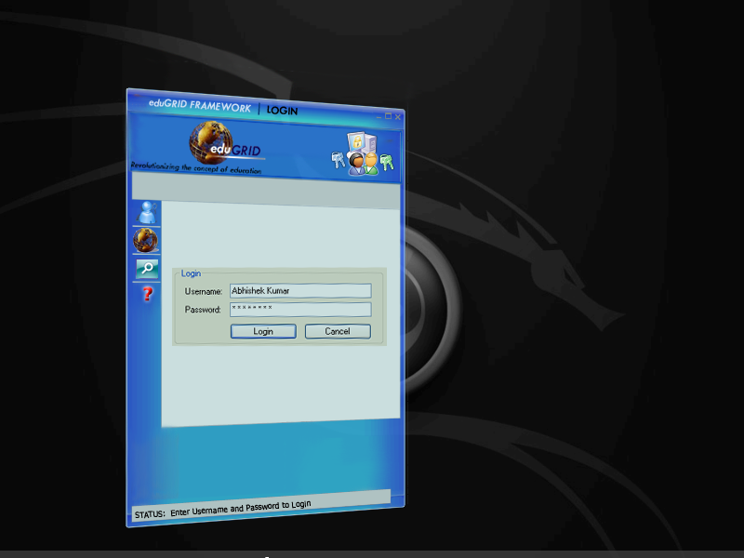

An overview of the User Interface for the Client Application – Login Screen.

3.2) Microsoft Windows Vista Sidebar Gadget
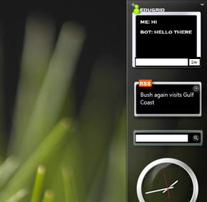

3.2) The Client Application for Students

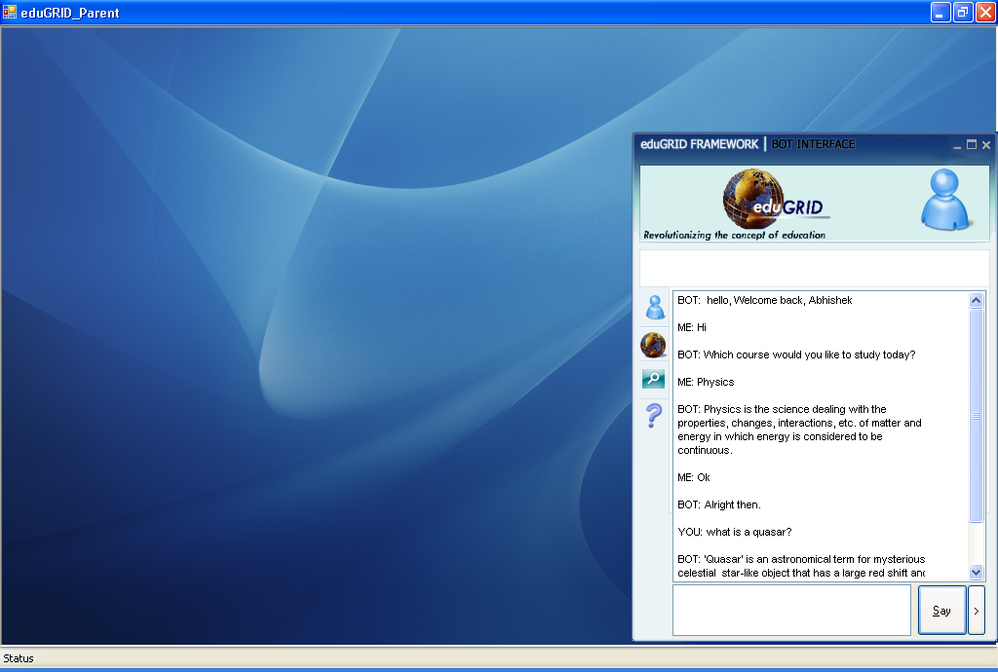
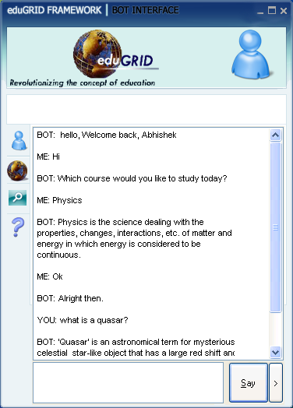
A Simple and easy to use interface

A course browser and a clock may also be displayed based on user preference

3.3) The Web Interface
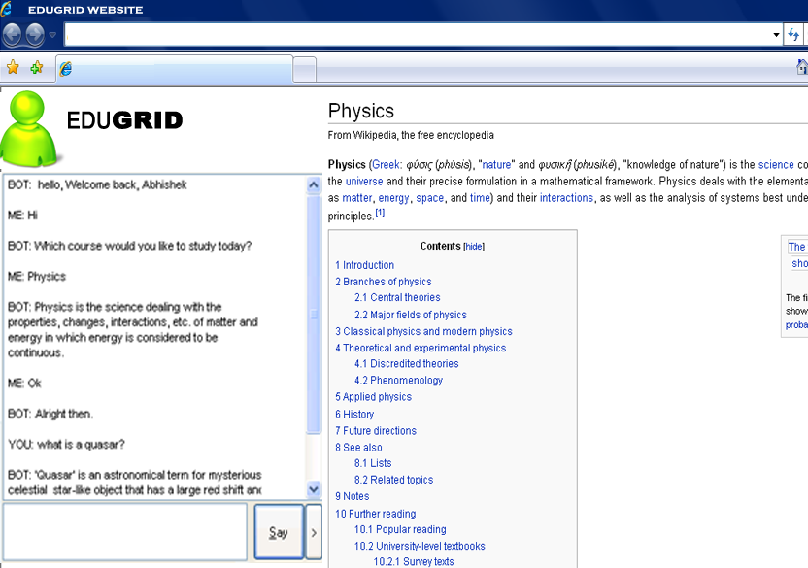

4. TWO IMPORTANT FUNCTIONS

4.1) Function #1: GridThread Execution In Application Domain (@Executor)

private void ExecuteThreadInAppDomain()
{
byte[] rawThread = null;
try
{
logger.Info("Started ExecuteThreadInAppDomain...");
logger.Info(string.Format("executing grid thread # {0}.{1}",
_CurTi.ApplicationId, _CurTi.ThreadId));
string appDir = GetApplicationDirectory(_CurTi.ApplicationId);
logger.Debug("AppDir on executor=" + appDir);
if (!_GridAppDomains.Contains(_CurTi.ApplicationId))
{
lock(_GridAppDomains)
{
// make sure that by the time the lock was acquired
//the app domain is still not created
if (!_GridAppDomains.Contains(_CurTi.ApplicationId))
{
// create application domain for newly encountered
//grid application
logger.Debug("app dir on executor: " + appDir);
//before initializing clear dir..
foreach (string F in Directory.GetFiles(appDir))
{
try //becoz exception should not be created
//for an issue as small as this
{
File.Delete(F);
}
catch (Exception ex)
{}
}
FileDependencyCollection manifest =
Manager.Executor_GetApplicationManifest(Credentials,
_CurTi.ApplicationId);
if (manifest != null)
{
foreach (FileDependency dep in manifest)
{
try //so that IO error doesnt occur if files
//already exist
{
logger.Debug("Unpacking file: " + dep.FileName +
" to " + appDir);
dep.UnPackToFolder(appDir);
}
catch (Exception ex)
{}
}
}
else
{
logger.Warn("Executor_GetApplicationManifest from the
Manager returned null");
}
--→ continued on next page…

--→ continued from previous page…

initialize_GridThreadExecutor();

_GridAppDomains.Add(
_CurTi.ApplicationId,
New GridAppDomain(GridThreadApplicationDomain,
GridThreadExecutor)
);

logger.Info("Created app domain, policy, got instance of
GridAppDomain and added to hashtable...all done
once for this application");
}
else
{
logger.Info("I got the lock but this app domain is already
created.");
}
}

//get thread from manager
GridAppDomain gad =
(GridAppDomain) _GridAppDomains[_CurTi.ApplicationId];

rawThread = Manager.Executor_GetThread(Credentials, _CurTi);
logger.Debug("Got thread from manager. executing it:
"+_CurTi.ThreadId);

//execute it

byte[] finishedThread = gad.Executor.ExecuteThread(rawThread);
logger.Info(string.Format("ExecuteThread returned for thread #
{0}.{1}", _CurTi.ApplicationId, _CurTi.ThreadId));

//set its status to finished
Manager.Executor_SetFinishedThread(Credentials, _CurTi,
finishedThread, null);
logger.Info(string.Format("Finished executing grid thread #
{0}.{1}", _CurTi.ApplicationId, _CurTi.ThreadId));
}
catch (ThreadAbortException)
{
if (_CurTi!=null)
logger.Warn(string.Format("aborted grid thread # {0}.{1}",
_CurTi.ApplicationId, _CurTi.ThreadId));
else
logger.Warn(string.Format("aborted grid thread #
{0}.{1}",null, null));
Thread.ResetAbort();
}

--→ continued on next page…

--→ continued from previous page…

catch (Exception e)
{
logger.Warn(string.Format("grid thread # {0}.{1} failed ({2})",
_CurTi.ApplicationId, _CurTi.ThreadId, e.GetType()),e);
try
{
//some exceptions such as Win32Exception caused problems when
passed directly into this method.
//so better create another new exception object and send it over.
Exception eNew = new Exception(e.ToString());
Manager.Executor_SetFinishedThread(Credentials, _CurTi,
rawThread, eNew);
}
catch (Exception ex1)
{
if (_CurTi!=null)
{
logger.Warn("Error trying to set failed thread for App:
"+_CurTi.ApplicationId+", thread="+_CurTi.ThreadId + ".
Original Exception = \n" + e.ToString(),ex1);
}
else
{
logger.Warn("Error trying to set failed thread: Original
exception = " + e.ToString(), ex1);
}
}
}
finally
{
_CurTi = null;
_ReadyToExecute.Set();
logger.Info("Exited ExecuteThreadInAppDomain...");
}
}

4.2) Function #2: The AIML chat Function

public Result Chat(Request request)
{
Result result = new Result(request.user, this, request);
if (this.isAcceptingUserInput)
{
// Normalize the input
AIMLLoader loader = new AIMLLoader(this);
AIMLbot.Normalize.SplitIntoSentences splitter = new
AIMLbot.Normalize.SplitIntoSentences(this);
string[] rawSentences = splitter.Transform(request.rawInput);
foreach (string sentence in rawSentences)
{
result.InputSentences.Add(sentence);
string path = loader.generatePath(sentence,
request.user.getLastBotOutput(), request.user.Topic,
true);
result.NormalizedPaths.Add(path);
}
// grab the templates for the various sentences from the graphmaster
foreach (string path in result.NormalizedPaths)
{
Utils.SubQuery query = new SubQuery(path);
query.Template = this.Graphmaster.evaluate(path, query,
request, MatchState.UserInput, new StringBuilder());
result.SubQueries.Add(query);
}
// process the templates into appropriate output
foreach (SubQuery query in result.SubQueries)
{
if (query.Template.Length > 0)
{
try
{
XmlNode templateNode =
AIMLTagHandler.getNode(query.Template);
string outputSentence =
this.processNode(templateNode, query, request,
result, request.user);
if (outputSentence.Length > 0)
{
result.OutputSentences.Add(outputSentence);
}
}

catch (Exception e)
{
if (this.WillCallHome)
{
this.phoneHome(e.Message, request);
}
this.writeToLog("WARNING! A problem was encountered
when trying to process the input: " +
request.rawInput + " with the template: \"" +
query.Template + "\"");
}
}
}
}
else
{
result.OutputSentences.Add(this.NotAcceptingUserInputMessage);
}
// populate the Result object
result.Duration = DateTime.Now - request.StartedOn;
request.user.addResult(result);
return result;
}

--→ End of code section ←--

5. ARCHITECTURE DIAGRAM

5.1) High level Overview Diagram (Abstract view)





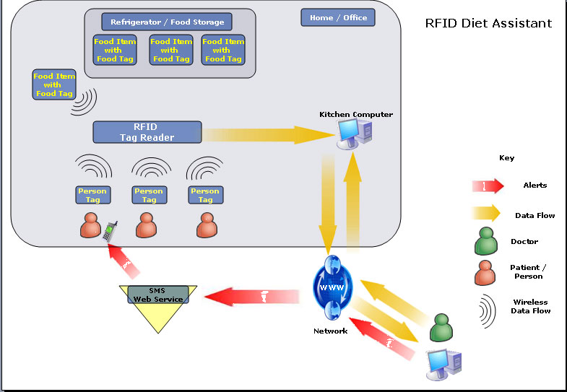
(in order to avoid clutter, various sub-components and interactions have not been displayed here; they have been shown in subsequent diagrams.)
Target Users

Students
Teachers
Researchers
Other Users
User Interface
Modes
eduGRID
Application
Manager
Client App

Sidebar Gadget

Ms Office Integration

Webservice

Smart Devices
Central GRID Manager
Generic Executor Pool
Several Specialized Executor Pools with sub managers
Learn Assistant
Live Search API
The World Wide Web

5.2) Executor Architecture

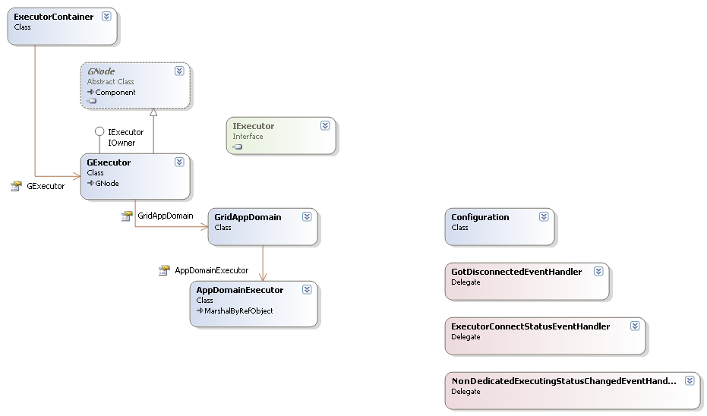
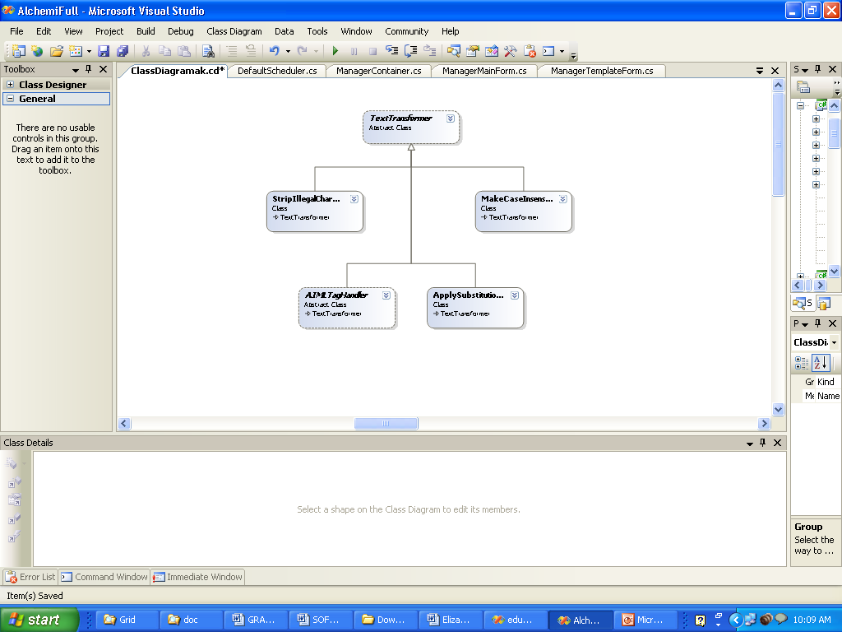

Cache
The GRID Thread Executor
The AIML Bot Class
INSIDE AN EXECUTOR NODE

5.3) Manager Architecture
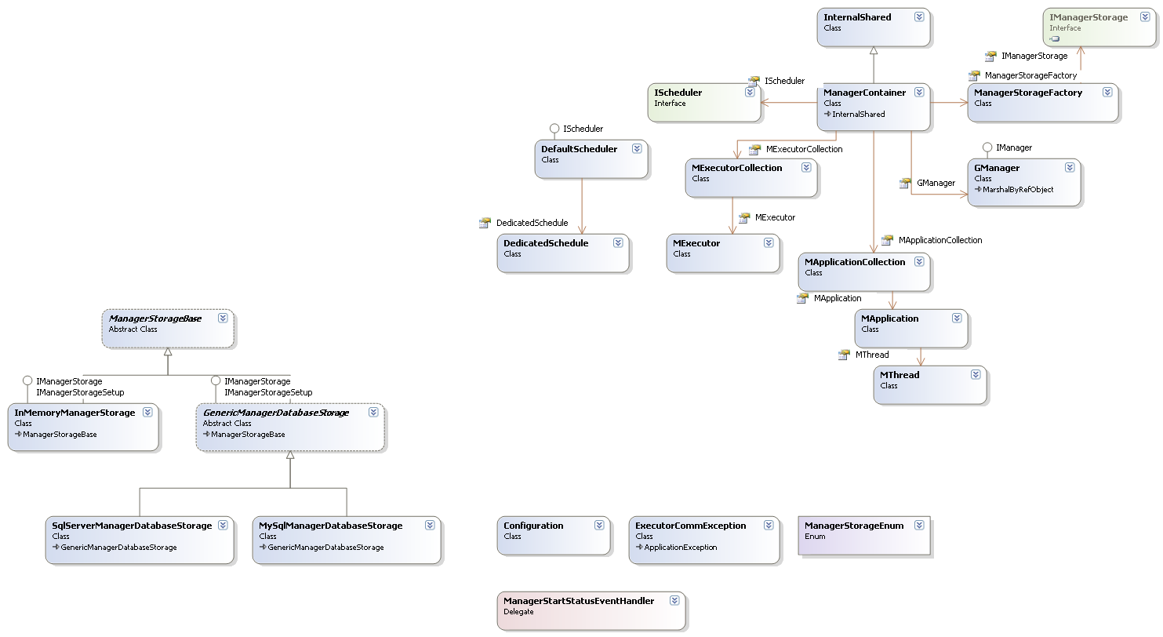
The GRID Manager
The Scheduler
INSIDE A MANAGER NODE
Other Managers of further GRID pools which are of higher specialization level

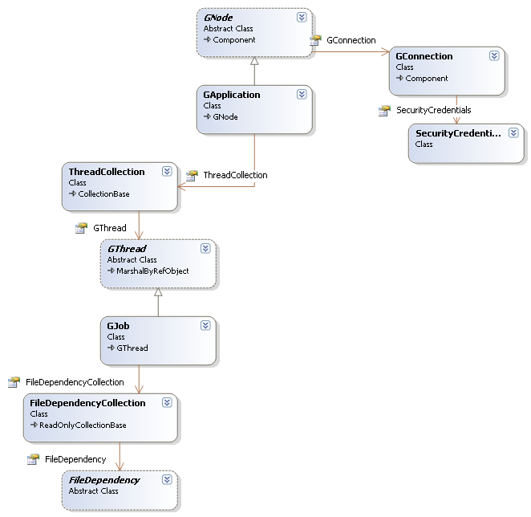
5.4) Grid Application Architecture - General

6. BRIEF DESCRIPTION OF WORKING

6.1) The GRID framework

6.1.1) Introduction to the GRIDs
- The idea of meta-computing - the use of a network of many independent computers as if they were one large parallel machine, or virtual supercomputer - is very compelling since it enables supercomputer-scale processing power to be had at a fraction of the cost of traditional supercomputers.
- While traditional virtual machines (e.g. clusters) have been designed for a small number of tightly coupled homogeneous resources, the exponential growth in Internet connectivity allows this concept to be applied on a much larger scale.
- This, coupled with the fact that desktop PCs in corporate and home environments are heavily underutilized – typically only one-tenth of processing power is used – has given rise to interest in harnessing the vast amounts of processing power that is available in the form of spare CPU cycles on Internet- or intranet-connected desktops.
- This new paradigm has been dubbed Grid Computing.

6.1.2) How Alchemi Works

Alchemi is a .NET grid computing framework that allows us to painlessly aggregate the computing power of intranet and Internet-connected machines into a virtual supercomputer (computational grid) and to develop applications to run on the grid.

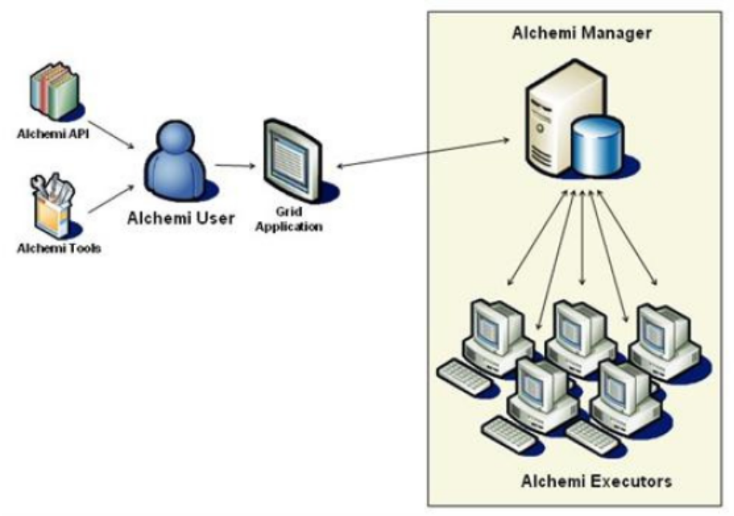
There are four types of distributed components (nodes) involved in the construction of Alchemi grids and execution of grid applications: Manager, Executor, User & Cross-Platform Manager.
BROAD OVERVIEW OF AN ALCHEMI GRID

6.1.3) Why we chose Alchemi

The Alchemi grid computing framework was conceived with the aim of making grid construction and development of grid software as easy as possible without sacrificing flexibility, scalability, reliability and extensibility. The key features supported by Alchemi are:
- Internet-based clustering [20][21] of desktop computers without a shared file system;
- federation of clusters to create hierarchical, cooperative grids;
- dedicated or non-dedicated (voluntary) execution by clusters and individual nodes;
- object-oriented grid thread programming model (fine-grained abstraction); and
- web services interface supporting a grid job model (coarse-grained abstraction) for cross-platform
- interoperability e.g. for creating a global and cross-platform grid environment via a custom
- Resource broker component.
- An Open source project and easily modifiable source. We have made heavy modifications to the scheduling mechanism of the manager and have integrated the bot into a separate AppDomain within the Executor.
6.1.4) Our GRID framework

We have used the Alchemi Framework to construct the grid framework to be used by our bots.
- The central Application manager is responsible for interacting with a cluster of executors at the first level – called the generic execution pool because they host the aiml files for the General Knowledge KB. The bots hosted on this cluster can reply to a variety of topics without going into detail.
In general, these bots would reply to queries assuming that a layman is asking them.
In case it does not find an answer, it will forward the query to the specialized GRID on basis of a periodically updated index.
- After the Central Manager comes the generic execution pool, which also has a manager and various executors. A load balancing algorithm is used to effectively utilize the GRID.
- In case the user is an expert in his field, or the query is not answerable by the generic bots, they are forwarded to specialized bots that are searched using a scheduling algorithm to make use of the parallel computation power of the grid.














Generic Executor Pool
Specialized Executor Pool

User
Manager
BizTalk
Target Users

Students
Teachers
Researchers
Other Users
User Interface
Modes
eduGRID
Application
Manager
Client App

Sidebar Gadget

Ms Office Integration

Webservice

Smart Devices
Central GRID Manager
Generic Executor Pool
Several Specialized Executor Pools with sub managers
Learn Assistant
Live Search API
The World Wide Web

6.2) Working of the Intelligent Bot

6.2.1) Introduction

Imagine that you can talk with your computer in natural language and she understands what you say. We are not referring to voice activated word processors. Goal is something like Mr. DATA in star trek.

Imagine for deciding about a subject you consult with your computer and make a brain storming session that is helpful. Or talk with a complicated database system and getting results instead of writing SQL code.

Applications of a natural language-processing program that can do logical reasoning are unlimited. This project is a step in this direction.

6.2.2) Brief Overview of System

This system is an artificial intelligence entity, with the power of NLP, as a virtual teacher for learning and assessment available for student use.
It has a logical reasoning engine and uses two knowledge bases, one for statistical inference and the other for rules of English grammar and general knowledge to facilitate learning. It provides lessons in inferential statistics.
The user can ask questions in English and have a dialogue with virtual teacher. It searches its knowledge bases (KB), uses its first order predicate logic reasoning engine and converses with the student using its Natural Language Processing (NLP) sub-system. It is aimed to provide a multimedia experience.
STUDENT
What is …?
What do you mean by…?
Answer is …
INPUT/OUTPUT INTERFACES

Text
Voice
Logical
Reasoning
Module
Natural Language
Processing
Module

General Knowledge KB
Subject Specific KB
User Profile
Schematic Diagram of Bot Design

6.2.3) The Data Storage Mechanism
The eduGRID bot uses an AIML interpreter to extract data from AIML files. AIML is the abbreviation for Artificial Intelligence Markup Language. It is an easy to use XML type language for communicating with and teaching the bot.
The AIML database contains 3 types of information
- General Knowledge KB
This Knowledge Base is used to store general information regarding various topics and is mainly used for intelligent conversation with the user. Currently, our bot has about 31,000 categories in its general knowledge Base.
- Subject Specific KB
This stores information regarding specific fields EG Healthcare, Archaeology etc… It is mainly hosted within the specialized execution pool and its services are called for only when the general execution pool(General bots) are unable to find a suitable reply to the user query.
- User Profile KB
This is used to store personalized user information. For e.g., the health profile of a user, personal information like telephone number etc…
<?xml version="1.0" encoding="ISO-8859-1"?>
<aiml>
<category><pattern>THE JRES *</pattern><template>I'm not an expert on JRE's.</template></category>

<category><pattern>JAVA *</pattern><template>You can download the latest Java release from <a target="_new" href="http://java.sun.com">java.sun.com</a>.</template></category>

<category><pattern>A JAVA *</pattern><template>Developments in Java interest me greatly.</template></category>

<category><pattern>WHAT ARE DEPRECATED *</pattern><template> <br/> One of the biggest challenges facing a Java application<br/> developer is finding a "lowest common denominator" subset of the<br/> Java language that works on all the platforms and versions<br/> out there. The Java language itself is a moving target.<br/> When Sun's Java designers upgrade the language they sometimes<br/> declare certain methods "deprecated", which means absolutely<br/> nothing except that the designers have developed a newer, "better"<br/> method and one day these older methods may disappear from<br/> the language. Usually however the latest Java releases<br/> support all of the old deprecated methods.<br/> <br/> </template></category>
<category><pattern>A WEB SITE</pattern><template>Can you give me the specific URL?</template></category>
ONE OF THE AIML FILES: Demonstration of Storage mechanis in xml based aiml

7. CONCLUSION

eduGRID is the solution to todays shortage of qualified teachers in the face of exploding population; in fact it is the solution to the shortage of teachers itself. eduGRID essentially will be a cluster of computers running an Artificially Intelligent program that will not only intelligently answer queries of students and teachers alike, but will eventually become the educator. students and teachers will login to the eduGRID and can learn through interactive tutorials or simply post questions to which the intelligent bot will reply - crisp and to the point. The ability to follow conversations and adapt to the each individual person's tastes will make it a more effective teaching aid if not a replacement itself.
eduGRID enables better education for people in urban and rural areas and provides opportunities for interaction and learning.

All these Applications provide innovative business models for our project making it an ideal platform to serve the public as well as an opportunity to earn revenue.

